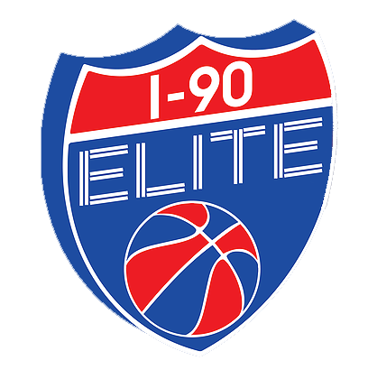
DONATION FORM
DONOR INFORMATION
DONOR NAME
DONOR ADDRESS
CITY/STATE/ZIP
AMOUNT OF DONATION – CHECK ONE
ELITE LEVEL SPONSORSHIP: |  | $2500.00
ELITE DONORS MAY HAVE NAME / LOGO INCLUDED ON THE BACK OF THE TEAM SHOOTING SHIRT.
PLEASE CHECK HERE IF YOU WOULD LIKE YOUR NAME / LOGO INCLUDED:
PLEASE INCLUDE LOGO DESIGN WITH YOUR DONATION.
RED LEVEL SPONSORSHIP: |  | $1000.00
WHITE LEVEL SPONSORSHIP: |  | $750.00
BLUE LEVEL SPONSORSHIP: |  | $500.00
OTHER AMOUNT:
ALL DONORS WILL BE LISTED ON www.i90elite.com
PLEASE CHECK HERE IF YOU WOULD LIKE YOUR NAME / LOGO INCLUDED ON THE WEBSITE:
PLEASE INCLUDE LOGO DESIGN WITH YOUR DONATION.
PLEASE SEND YOUR TAX DEDUCTIBLE DONATION TO:
I-90 ELITE
c/o KARIN RYAN
8925 WILLIAMS COURT
CLARENCE CENTER, NY 14032

